How to Guide: Sprinklr Quick Search

- Login to your Sprinklr account: https://lite.sprinklr.com/login?tactic_id=2070368
- In your Sprinklr homepage, navigate to the top of the page to create a new search.

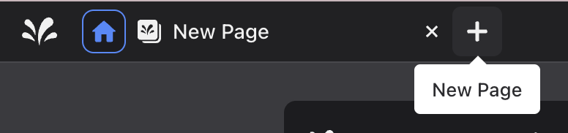

- On your new page, navigate into the ‘Sprinklr Insights’ tab and select ‘quick search’ located under the ‘Explorer’ subheading.

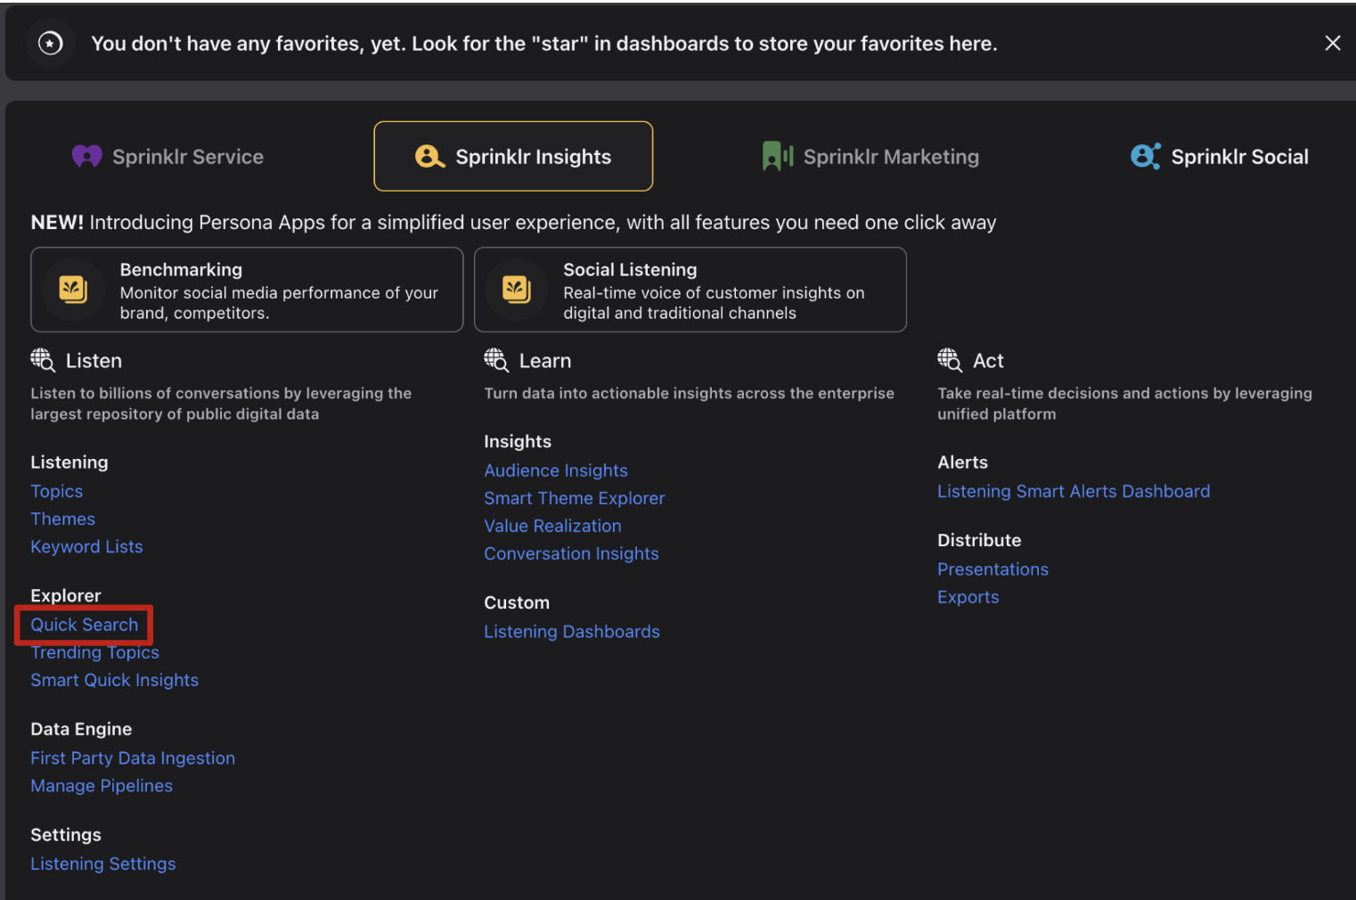

- Once quick search is selected, you’ll be given a search bar in which you can enter the keyword, phrases, or hashtags, using boolean operators such as "AND,” "OR," or “NOT” to search multiple queries at the same time or exclude certain phrases. Click Search.

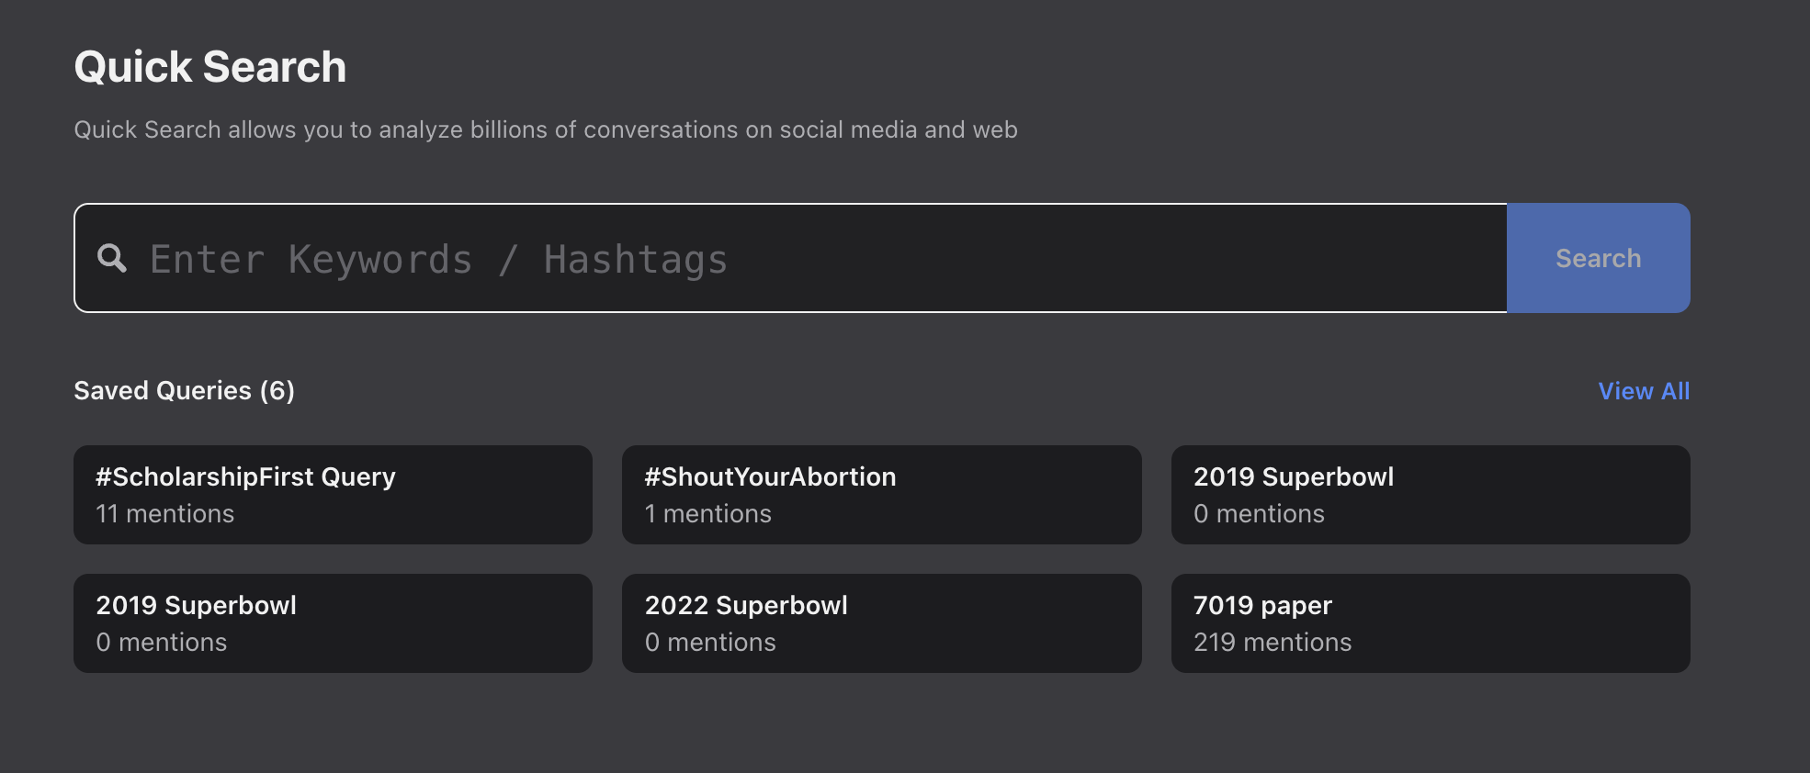

- To key further into your search the following operators can be used in the quick search feature with your keywords:

Operator | Syntax Example | Result
author | author “Mike the Tiger” | This will search for the posts/messages posted by Mike the Tiger.
title | title: lsu | This will search for the messages like review, heading, etc. whose titles contain LSU.
message | message: "Manship Student" | This will search for the messages that have manship student in their description/text.
userbio | userbio: "Manship Student" | This will search for mentions that have "Manship Student" in their profile bio.
sample | sample:50 | Filter mentions at the given sampled percentage (from 1 to 99)

A full list of operators and the features they can be used in can be found here: https://www.sprinklr.com/help/articles/faqs-and-advanced-usecases/refine-your-brand-research-using-search-operators-in-listening-advanced-queries/64590e20e66f2e36b4515e5c

- Your quick search will likely result in a large data set, therefore it is important to filter down the data to ensure your data set is relevant and meets your research needs. The dashboard should look as follows:

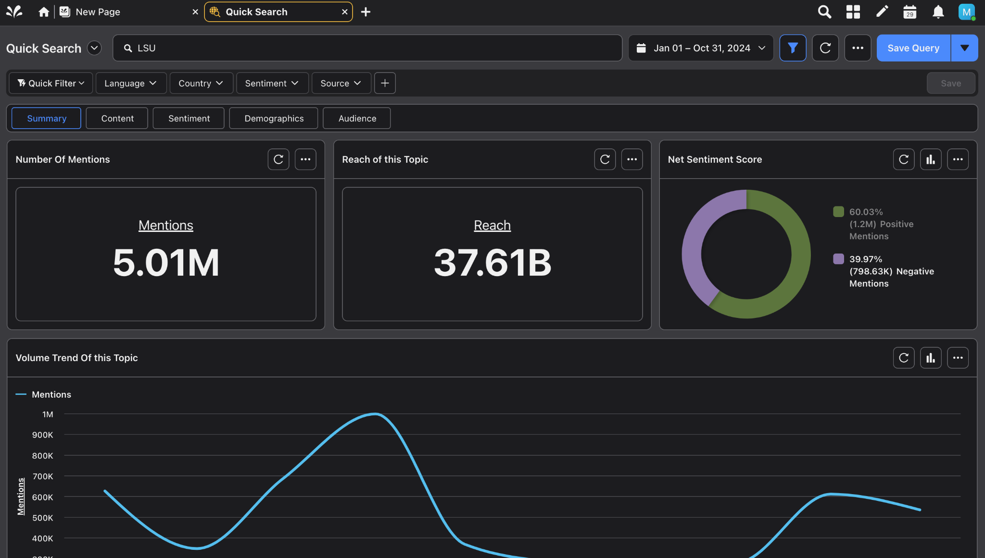

- First, to sort your data by time select the calendar icon in the right hand corner and adjust the date. You can select a custom date range or sort by preset date ranges such as ‘today,’ ‘yesterday,’ ‘last 24 hours,’ etc. Then select Apply.

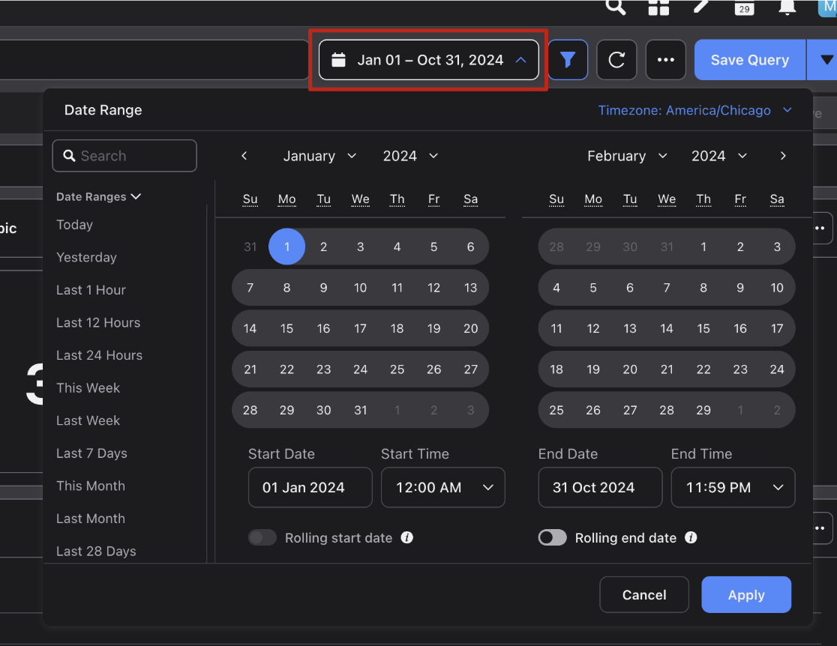
- Language, Country, and Source may be sorted through the top bar by selecting the drop-down menus. The source type is the social media platform you’d like to pull data from. Be aware that Instagram won’t pull much data this way and that Facebook will only pull publicly available posts from people and not business pages.

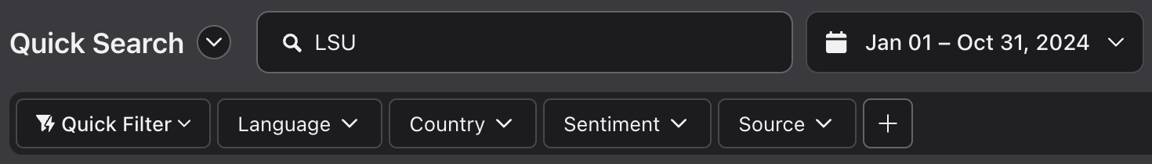

- To exclude specific types of content such as retweets or quote tweets, select the plus sign to add additional filters, select ‘message type,’ and select only the post types that you would like to include in your data set. Types that include ‘post’ such as ‘Reddit Post’ will include the original post from users.

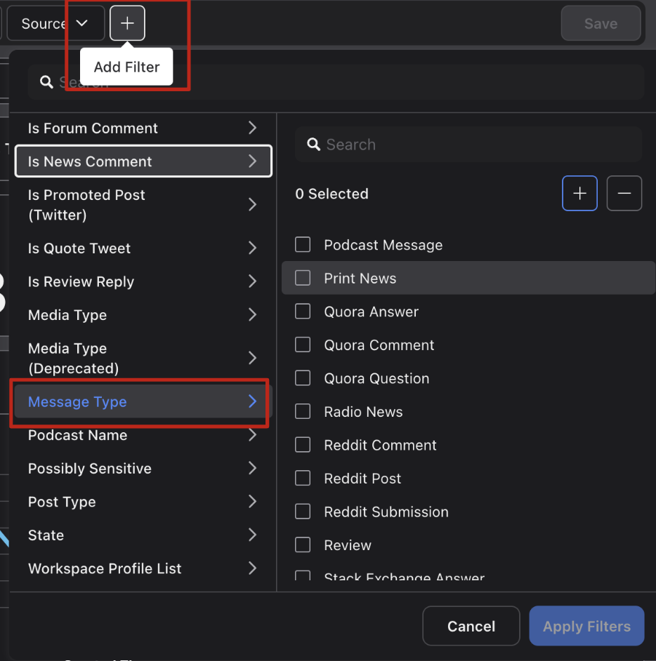

- To export the mentions you’ve collected and filtered. Navigate to ‘number of mentions,’ select the three dots in the right-hand corner of the box [...], and select ‘export widget.’ From here, the data can be exported as a PDF, PNG, CSV, or Excel file.

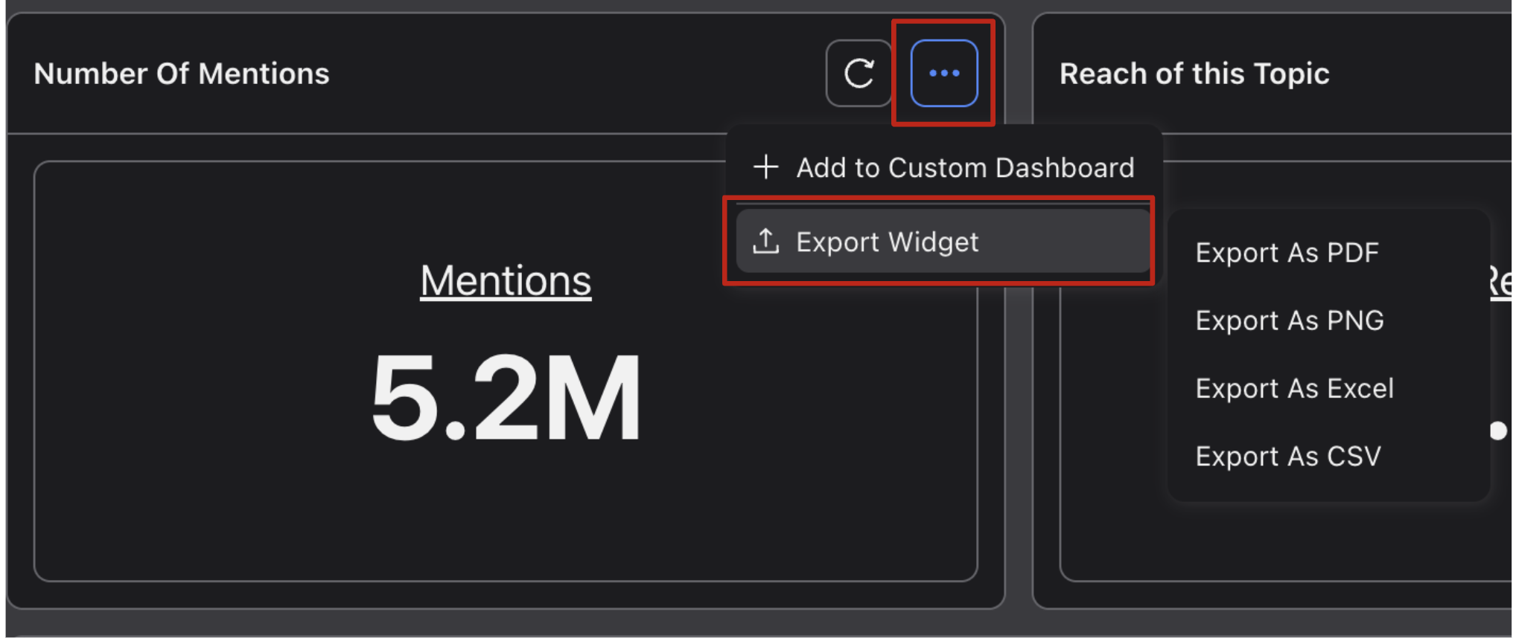

- To export the dashboard, navigate the three dots [...] at the top, right-hand corner of the dashboard and select ‘export.’
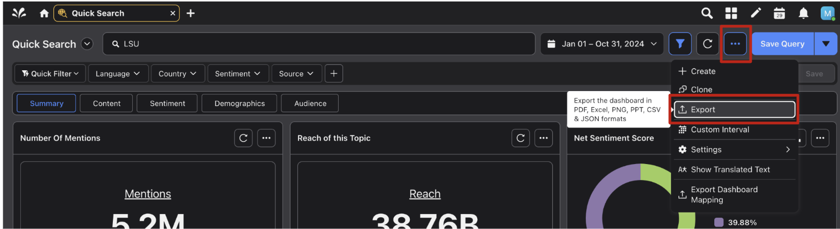

- Data downloads are capped at 10k posts/comments/messages. To exceed that cap, the dates have to be adjusted.

Requests for large downloads (e.g., 10K+) need to be authorized by the SMAC lab director, Dr. Ramirez, to ensure we don't exceed our yearly allotted download limits.

