LSU Manship School of Mass Communication
Social Media Analysis and Creation Lab

Guide to Downloading TikTok Data Using Chrome Extension

1. Download the Chrome Extension (myfaveTT): https://chromewebstore.google.com/search/myfaveTT%20-%20download%20all%20TikToks%20you've%20loved

2. Once installed, click the extension and it will open TikTok in the browser.
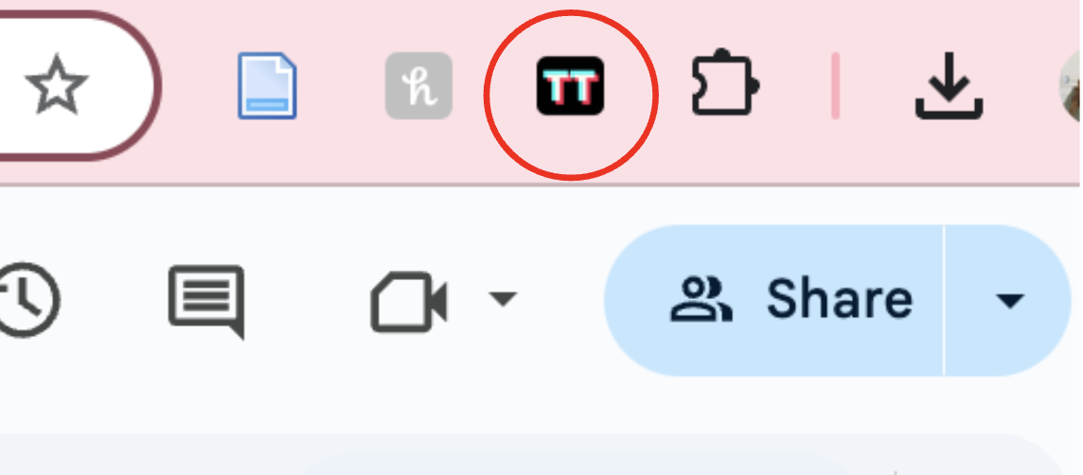

3. Log into your TikTok account in the browser.
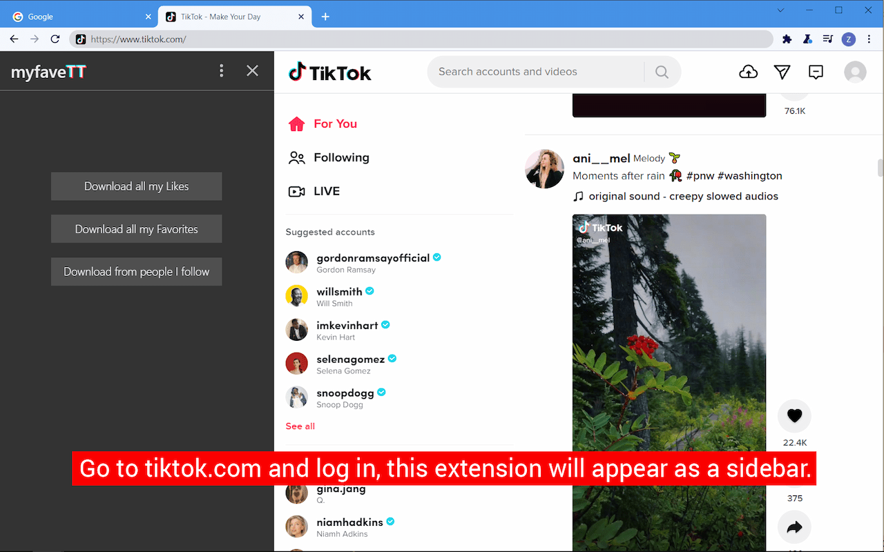

4. Like all the videos you want to save on your mobile TikTok app. The extension will pull any existing likes you have, but if you are looking to add new likes to your downloads, they must be liked in the mobile app (liking/saving in the browser doesn’t register properly for downloading purposes).
5. Double check that your likes appear in the browser.
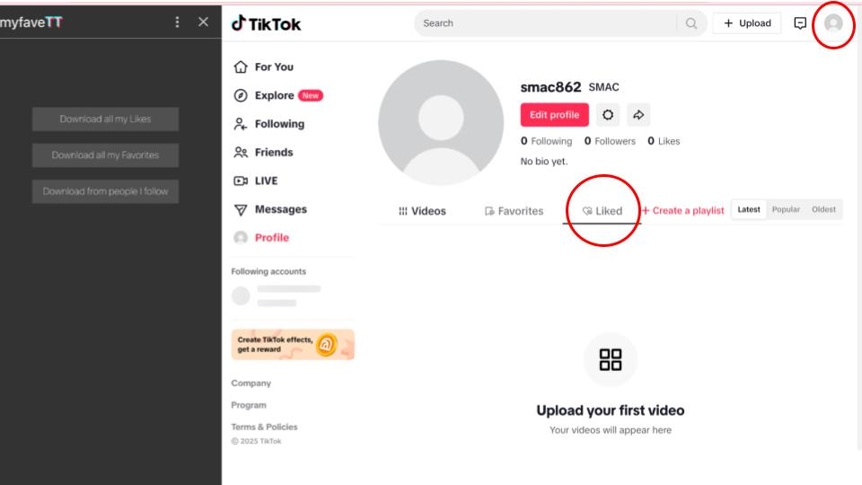

The same process is true for ‘favorites’ which are those saved with the bookmark icon. Saved videos can be sorted into separate ‘likes’ and ‘favorites’ folders for organization purposes.

6. Once you have liked/favorited your videos and ensured that they are present in the desktop app, you can now you can export all videos to a local folder.

On the side bar on the right, select which content you want to download: likes, favorites, and content from people you follow.

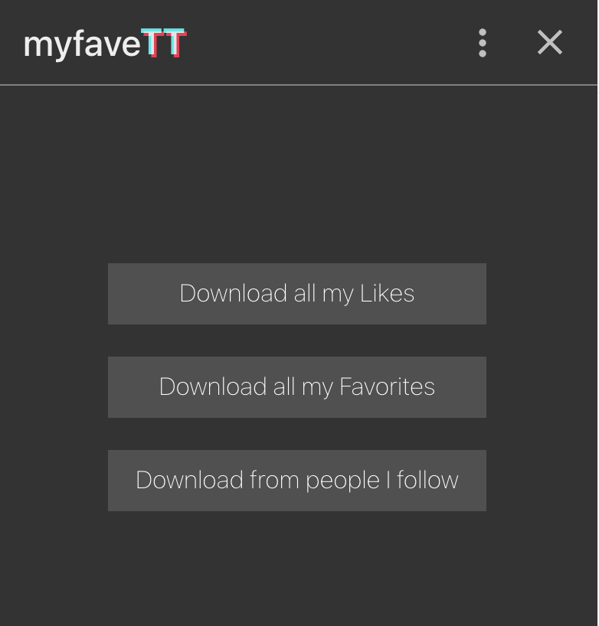

7. You’ll then be given the option to select the folder that you want to download to (location), and your download will initiate.

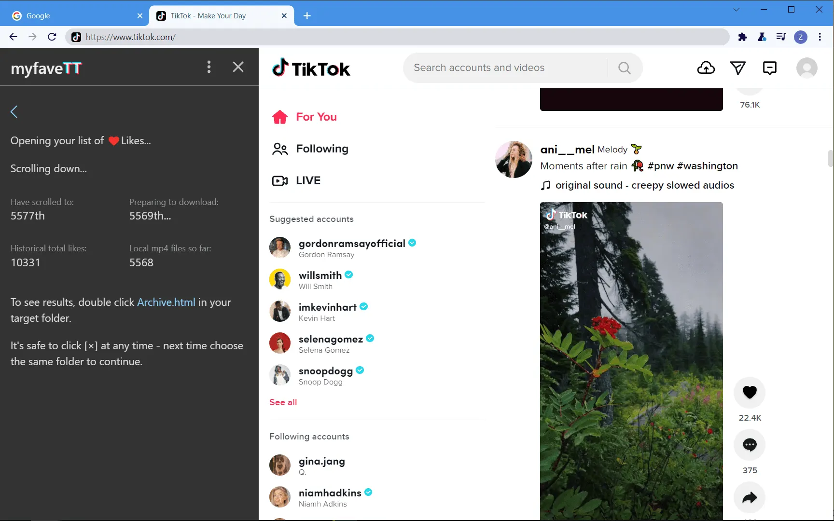

8. Once your download completes. Your folder will have three items: Archive.html, data, and instruction.txt.
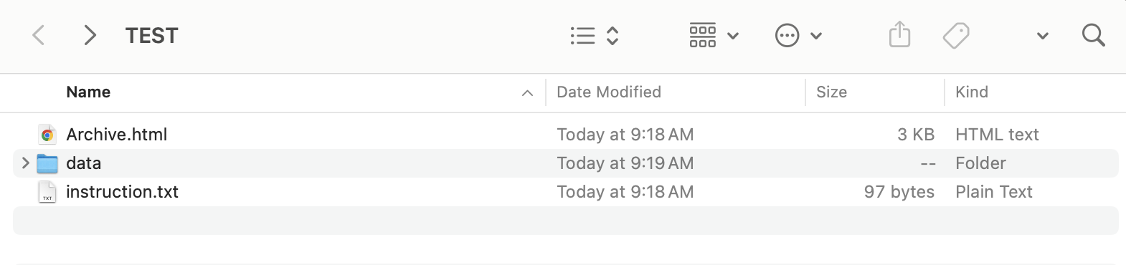

9. To view your .mp4 files (just the videos), select the data file. You will be given two options from there: covers (jpg images of the video) and videos (the actual .mp4 file).

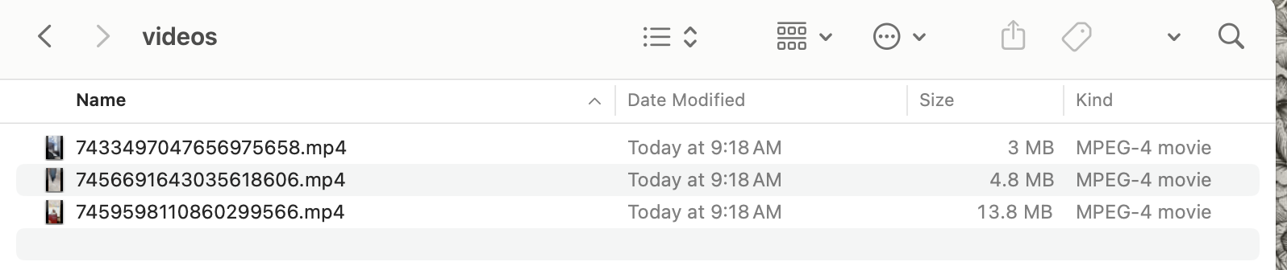

10. To access meta information about the videos you downloaded, including number of likes, author’s username, number of followers, video plays, video likes, date posted, and video caption, double click ‘Archive’ (or drag it to a browser) to browse / filter / sort / play your mp4 files.

